**Hands on 1**

**Spring Data JPA - Quick Example**

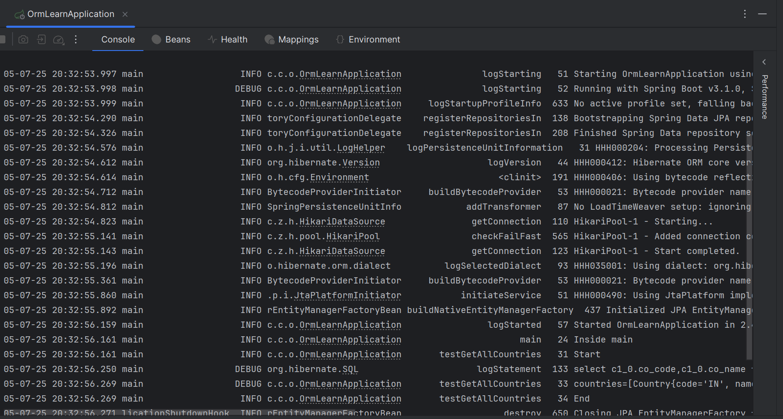

**Hands on 4**

**Difference between JPA, Hibernate and Spring Data JPA**

**Hibernate Output:**

Hibernate:

insert

into

employee

(name)

values

(?)

Employee added: com.example.model.Employee@4e25154f

**Spring JPA Output:**

Hibernate:

insert

into

employee

(name)

values

(?)

Employee added: Employee{id=1, name='John Doe'}